Worksheet Assignment: Results and Post-Lab Questions
Table 1: Zone of Inhibition for Skin Sample
Antibiotic Disk | Diameter of Zone (mm)
AM10
K30
Te30

Table 2: Zone of Inhibition for Yeast Sample
Antibiotic Disk | Diameter of Zone (mm)
AM10
K30
Te30

Table 3. Zone of Inhibition for Local Sample
Antibiotic Disk | Diameter of Zone (mm)
AM10
K30
Te30

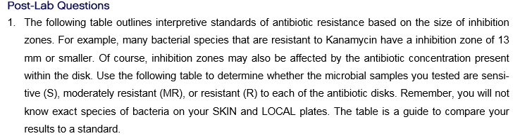

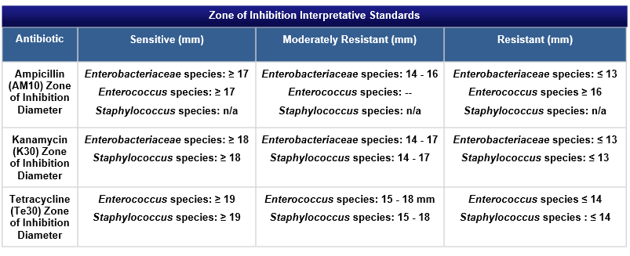
Post-Lab Questions

2. Is the bacterial lawn sampled from skin more resistant to one antibiotic over the others?

What about the local sample?

The yeast sample?

Use your results to support your answer.

3. Based on the following scientific paper (See Abstract of paper) why are there no diameters given for ampicillin and Staphylococcus?
http://www.bioline.org.br/pdf?ja04014

